Supplementary Material for High-Throughput and Low-Latency DrDoS Detection Using 2 Quantized ONNX Models

Validation-Training Loss and Accuracy Graphs for the CNN Model
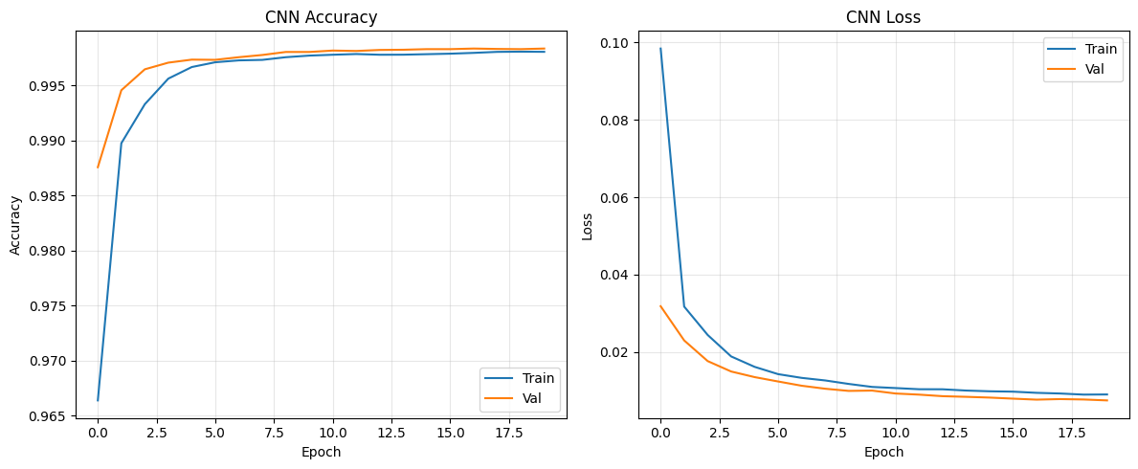
Validation-Training Loss and Accuracy Graphs for the GRU Model
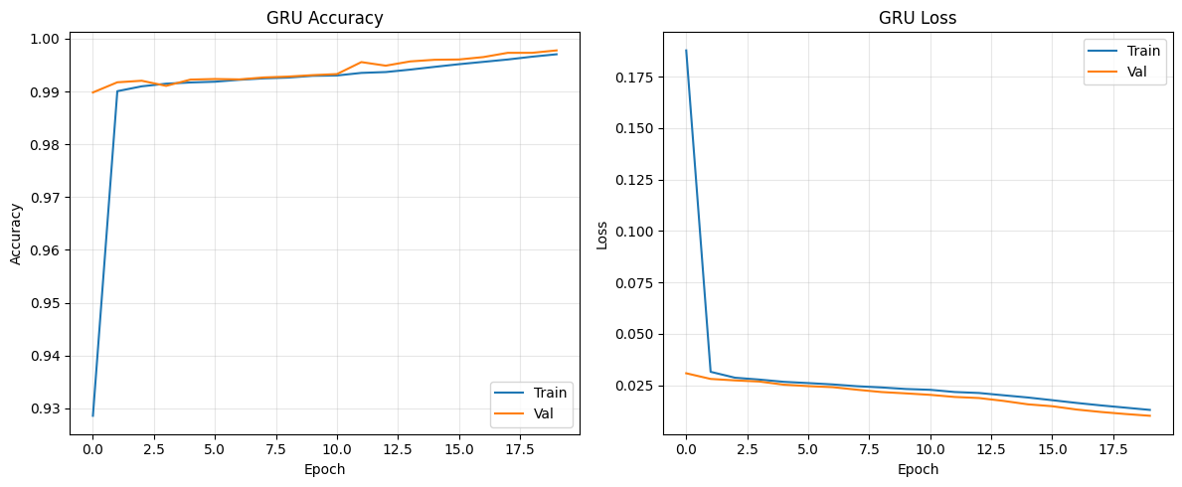
Test ROC Curve for the CNN Model
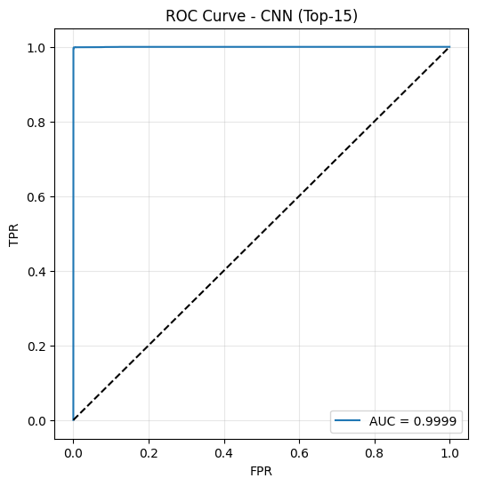
Test ROC Curve for the GRU Model
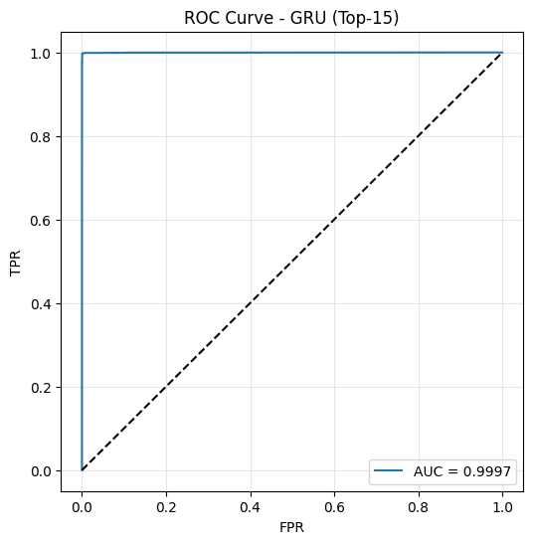
Confusion Matrix for the CNN Model
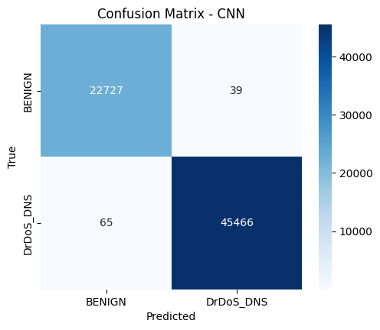
Confusion Matrix for the GRU Model
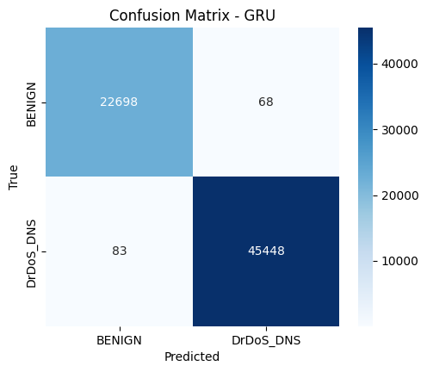
Training Time vs Batch Size (CNN)
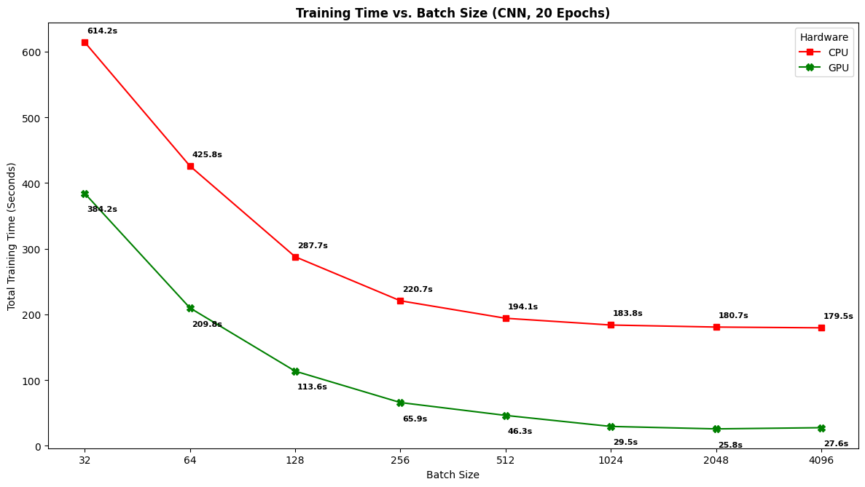
Training Time vs Batch Size (GRU)
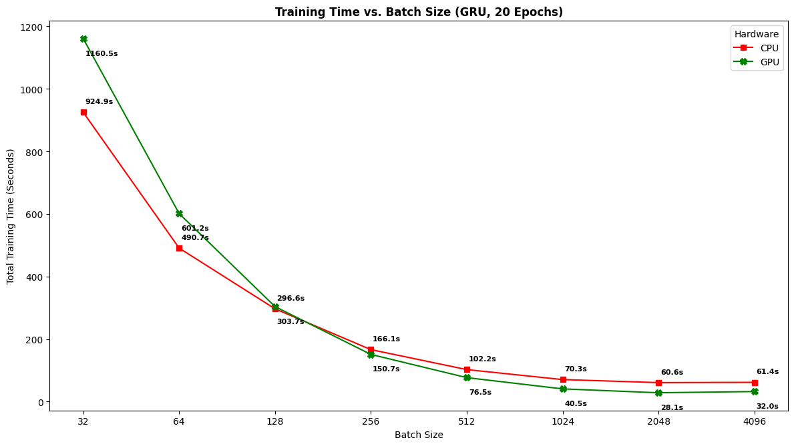
Throughput vs Batch Size (CNN)
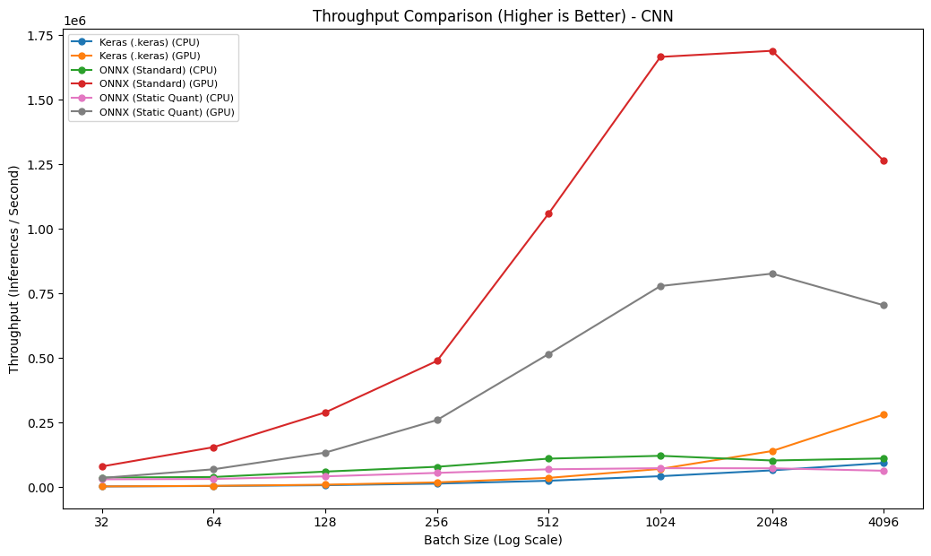
Throughput vs Batch Size (GRU)
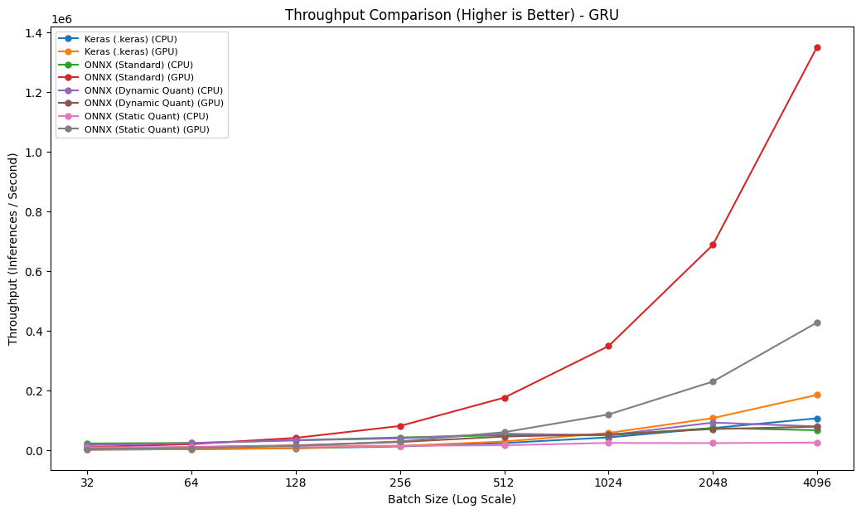
Latency vs Batch Size (CNN)
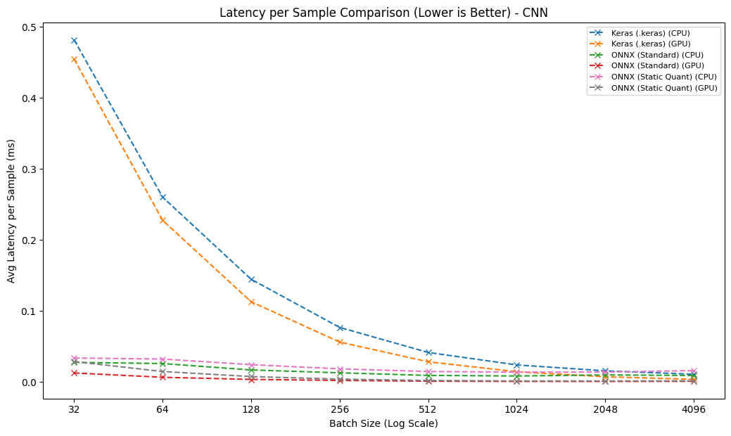
Latency vs Batch Size (GRU)
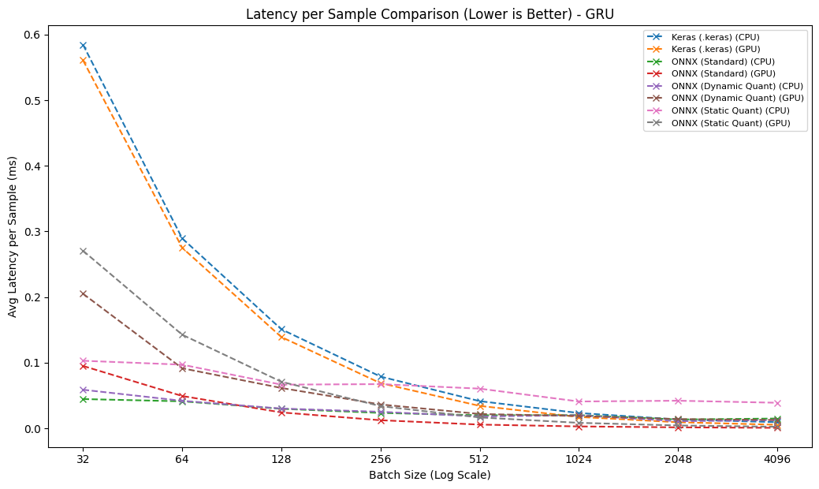
Table 3. CNN Model Comparison Summary.
Model | Environment | Inference Time (µs) | File size (MB)
Keras | CPU | 10.7489 | 0.7086
Keras | GPU | 3.5619 | 0.7086
ONNX | CPU | 8.2803 | 0.226
ONNX | GPU | 0.5917 | 0.226
Static Quantized ONNX | CPU | 13.7391 | 0.1056
Static Quantized ONNX | GPU | 1.2097 | 0.1056
Table 3. GRU Model Comparison Summary.
Model | Environment | Inference Time (µs) | File size (MB)
Keras | CPU | 9.3467 | 0.556
Keras | GPU | 5.3923 | 0.556
ONNX | CPU | 13.4195 | 0.2625
ONNX | GPU | 0.7397 | 0.2625
Dynamic Quantized ONNX | CPU | 10.8018 | 0.2534
Dynamic Quantized ONNX | GPU | 12.6615 | 0.2534
Static Quantized ONNX | CPU | 38.9413 | 0.7065
Static Quantized ONNX | GPU | 2.3361 | 0.7065

LIBRARY VERSIONS (reproducibility)
- python : 3.12.13
- platform : Linux-6.6.122+-x86_64-with-glibc2.35
- numpy : 2.0.2
- pandas : 2.2.2
- scikit_learn : 1.6.1
- scipy : 1.16.3
- matplotlib : 3.10.0
- seaborn : 0.13.2
- tensorflow : 2.20.0
- keras : 3.13.2
- onnx : 1.22.0
- tf2onnx : 1.17.0
- onnxsim : 0.6.5
- protobuf : 5.29.6
- onnxruntime_gpu (GPU inference) : 1.20.1
- onnxruntime_cpu (CPU inference / CNN dynamic-quant): 1.27.0
- cuda : 12.5.1
- cudnn : 9
- gpu : A100 [PhysicalDevice(name='/physical_device:GPU:0', device_type='GPU')]
- ONNX Runtime: GPU=onnxruntime-gpu 1.20.1 | CPU=onnxruntime 1.27.0 (iki ayri faz)
- Random seeds: global=42 | split=42 | downsample=27 | variance=1000-1029

All experiments were conducted on Google Colab using an NVIDIA A100 GPU (Linux 6.6.122, x86_64, glibc 2.35; CUDA 12.5.1, cuDNN 9). The software stack was: Python 3.12.13, TensorFlow 2.20.0 (Keras 3.13.2), NumPy 2.0.2, pandas 2.2.2, scikit-learn 1.6.1, SciPy 1.16.3, matplotlib 3.10.0, seaborn 0.13.2, ONNX 1.22.0, tf2onnx 1.17.0, onnxsim 0.6.5, and protobuf 5.29.6. ONNX inference was evaluated with two ONNX Runtime builds in separate sessions: ONNX Runtime-GPU 1.20.1 for GPU benchmarks—executed in a TensorFlow-free session to avoid GPU-memory contention—and ONNX Runtime 1.27.0 (CPU build) for CPU benchmarks, including the CNN dynamic-quantized model whose ConvInteger operator is implemented only in the CPU build. All random seeds were fixed to ensure determinism: a global seed of 42 (NumPy, Python random, and TensorFlow), random_state = 42 for the stratified train/test split, random_state = 27 for downsampling.

